|  |  |
| --- | --- |
| A picture of a winding road and trees  Prototype of monthly claim system  PROG6212 | PROG6212 – Part 1:  This is the prototype of the Monthly Claim System. In this document, I explain the structure and design of the system, show the UML class diagram, outline the project plan, and describe the GUI.  Sizwe Thandaza Majola  ST101143043 |

**Documentation:**

Design Choices and Structure

The system is built using ASP.NET Core MVC because it separates logic, data, and views cleanly. It also works well with relational databases. The GUI uses Bootstrap 5 so the layout is simple, responsive, and easy to use.

Database Structure

The database is relational. The main tables are:

- Users (UserId, Name, Email, PasswordHash, RoleId)

- UserRoles (RoleId, RoleName) – Lecturer, Coordinator, Manager

- Claims (ClaimId, LecturerId, HoursWorked, HourlyRate, Notes, Status, SubmittedDate, ReviewedBy, ReviewedDate)

- Documents (DocumentId, ClaimId, FileName, FilePath, UploadedDate)

- Reviews (ReviewId, ClaimId, ReviewerId, Decision, Comments, ReviewDate)

Relationships:

- One User has one Role.

- A Lecturer can submit many Claims.

- A Claim can have many Documents and Reviews.

- Reviews link a Claim to the Reviewer (Coordinator/Manager).

GUI Layout

- Lecturer View: Submit Claim form (name, email, hours, rate, notes, file upload), plus a list of claims with statuses.

- Admin View: Dashboard with counts of Pending, Verified, Approved, Declined. Claim details page with Approve/Verify/Decline actions.

Assumptions and Constraints

Assumptions

- Lecturers have internet access and valid emails.

- Admins are trained to use the system.

- Claims are submitted monthly and reviewed within 7 days.

- File uploads are limited to PDF, DOCX, XLSX.

Constraints

- Max file size: 10 MB.

- System must run on .NET 6 and SQL Server.

- Only authorized users can approve or decline claims.

- Prototype uses in‑memory storage (no persistent DB yet).

**UML Class Diagram for Monthly Claim System:**

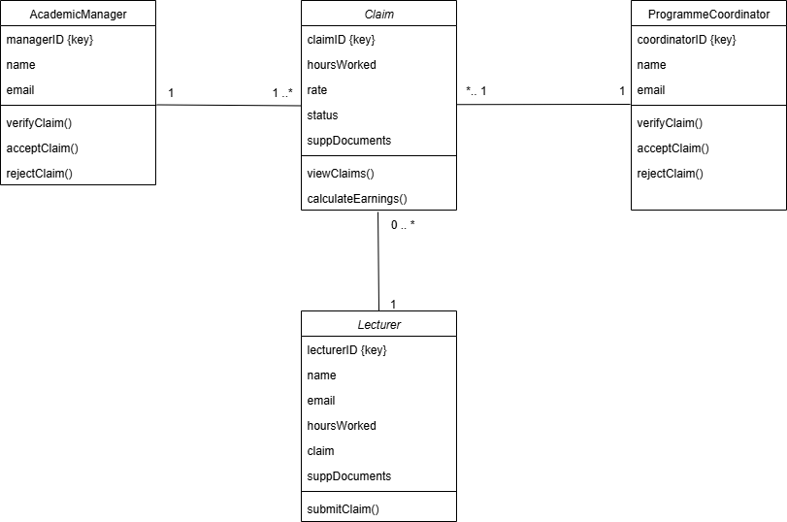

**Project Plan of Monthly Claims System:**

Project Plan

- Gather requirements and define the scope of the system (3 days)

- Design the database (ERD, UML class diagram, schema) (4 days)

- Build the Claim model and set up the ClaimDataStore (3 days)

- Create the Lecturer Claim submission form with file upload (4 days)

- Develop the Admin Dashboard to view and manage claims (4 days)

- Implement the claim status workflow (Pending → Verified → Approved/Declined) (3 days)

- Add file storage and linking of documents to claims (3 days)

- Write unit tests for claim add, approve, verify, deny, encryption, decryption (5 days)

- Run integration testing and fix issues (5 days)

- Finalize documentation, polish the GUI, and prepare for submission (3 days)

GUI: Design and User‑Friendliness

The GUI is simple and clean. Bootstrap makes it responsive.

- Lecturer Home: “Submit a New Claim” button and list of claims with statuses.

- Submit Claim Page: Form with all required fields and file upload.

- Admin Dashboard: Summary cards for claim counts, table of claims with action buttons.

- Claim Details: Shows claim info, documents, review history, and admin actions.

**Reference List:**

Satzinger, J.W., Jackson, R.B., and Burd, S.D, 2012. Systems Analysis and Design in a Changing World. 6th ed. Boston: Cengage Learning. Available at:

<<https://archive.org/details/systemsanalysisd0000satz>>

[Accessed 16 September 2025]